

SCHOOL OF COMPUTER SCIENCE AND ENGINEERING

**CASE STUDY ON H R_ANALYTICS**

**Submitted By: Rajeshwari G**

**Rukmini Knowledge Park,Kattigenahalli,Yelahanka,**

**Bengaluru-560064**

[**www.reva.edu.in**](http://www.reva.edu.in)

Visualizations using HR analytics in Power BI enable organizations to transform complex data into intuitive dashboards, providing actionable insights into employee performance, attrition rates, and workforce trends. These visual tools help HR professionals communicate key metrics effectively to stakeholders. Visualizations using HR analytics in Power BI enable organizations to transform complex data into intuitive dashboards, providing actionable insights into employee performance, attrition rates, and workforce trends. These visual tools help HR professionals communicate key metrics effectively to stakeholders.

**Here, we are analyzing the count of employees,Arttrition count,Attrition Rate,Average of Age,Average of Salary,Average of Experience:**

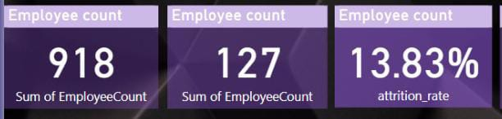

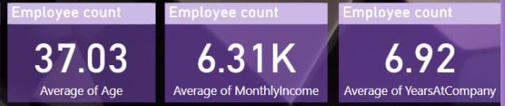

**Here,we are analyzing the Sum of Attrition count by Age Group:**

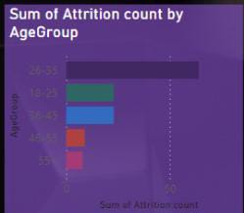

**Here,we are analyzing the Sum of Education by Education Field :**

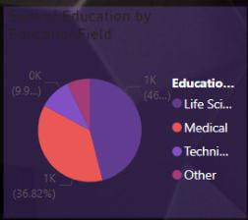

**Here,we are analyzing the Sum of Attrition Count by Salary Slab:**

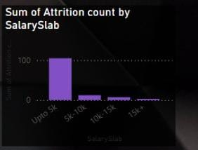

**Here,we are analyzing the matrix for Job Role as Rows,Job Satisfaction as Columns to the Attrition Count:**

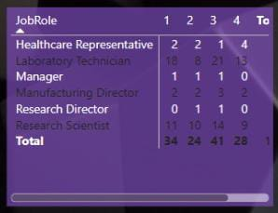

**Here,we are analyzing the Sum of Attrition Count By Gender:**

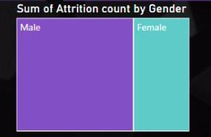

**Here,we are analyzing the slicer for Department:**

